User Guide – Document Knowledge Transfer /
Policy & Attestation
CoMA EOHHS - Dept. of Developmental Services
12/15/22

Table of Contents
Document Properties 2
Version History 2
Accessing Knowledge Transfer 3
Unread Documents Screen 3
Open Knowledge Transfer Manually 4
Knowledge Transfer Interface 5
Usage Policy Pop-Up 5
Reading Group List 6
Document LIst 8
Document List Refinement 10
Viewing a Document 13
Acknowledging a Document 15
Adding as a Reference 16

Document Properties

Version History
Version | Date | Author | Description
1.0 | 2022.12.15 | Tim Richard | Creation of draft documentation

Accessing Knowledge Transfer
To Review and Acknowledge documents you will need access to:

- OnBase Web Client

Access the web client via this URL:
UT1: https://massddsut1.hylandcloud.com/221dds/
Prod: https://massdds.hylandcloud.com/221dds/

Unread Documents Screen
If you have any unread documents, you will be presented with this screen upon login.
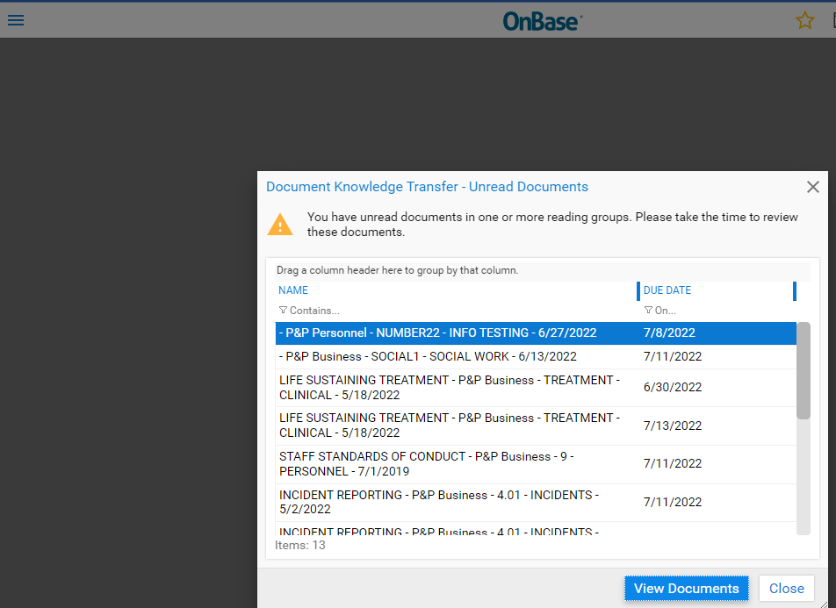

To access Knowledge Transfer from this screen, click View Documents.
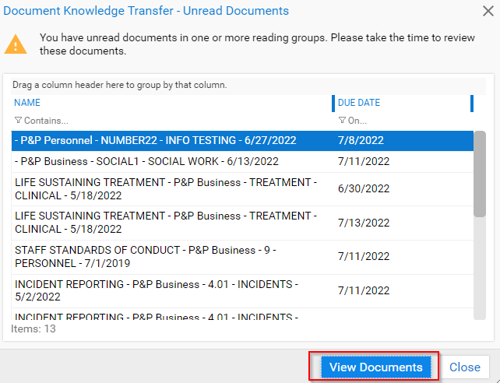

Open Knowledge Transfer Manually
If instead click Close or don’t have any unread documents, you can access Knowledge Transfer from the menu. Click the stacked, three lines in the top left of the client. This is known as a “hamburger menu.”
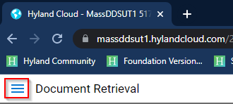

This will open the left panel. Find the Knowledge Transfer heading and click Open Knowledge Transfer. The other items on this menu, like Document Retrieval and Workflow may not be shown for you.
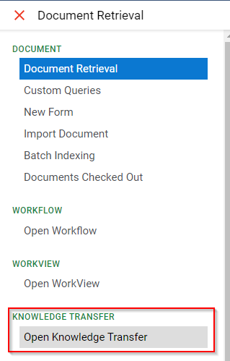

Knowledge Transfer Interface
Regardless of which manner you use to open Knowledge Transfer, you will be taken to this interface.

Usage Policy Pop-Up
Upon accessing Knowledge Transfer, you will get this pop-up message explaining the timeline for and definition of acknowledgement. Click OK to be taken to the document list.
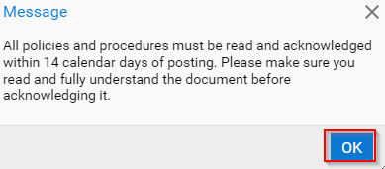

Reading Group List
The left panel shows a list of Reading Groups to which you belong.
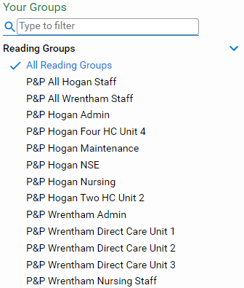

You can use the search field under the Your Groups heading to filter the list of groups.
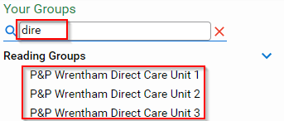

Click the red X or clear the field to bring back the full list
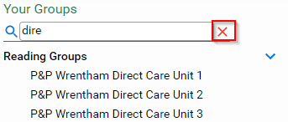

Click All Reading Groups to see documents assigned to you across all groups.
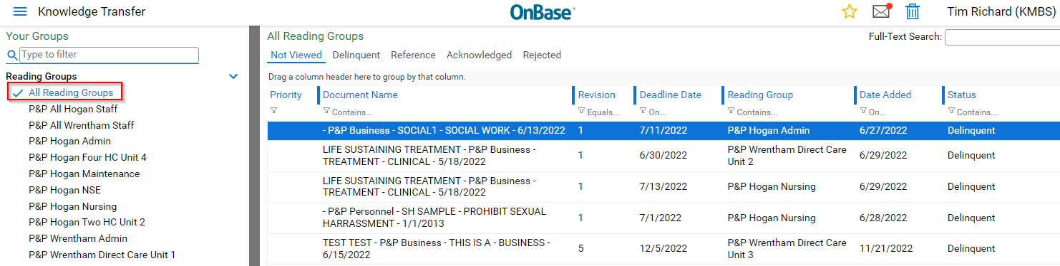

Note the status counts that appear below the Reading Groups list.
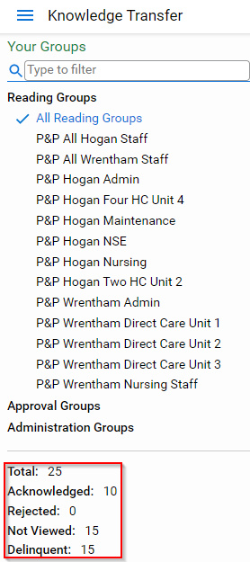

Alternatively, click a specific group to just see documents assigned to from that group. 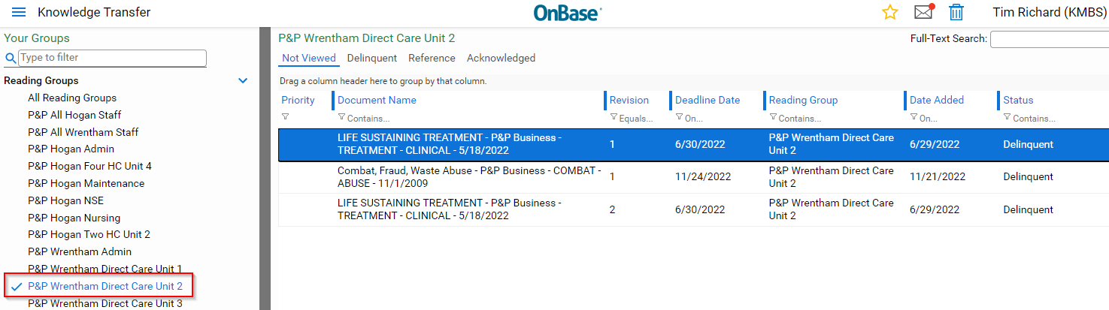

Note the status counts are filtered to only those for All Hogan Staff
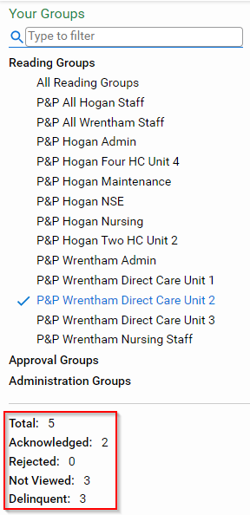

Document LIst
The documents are grouped into categories by status.

Not Viewed
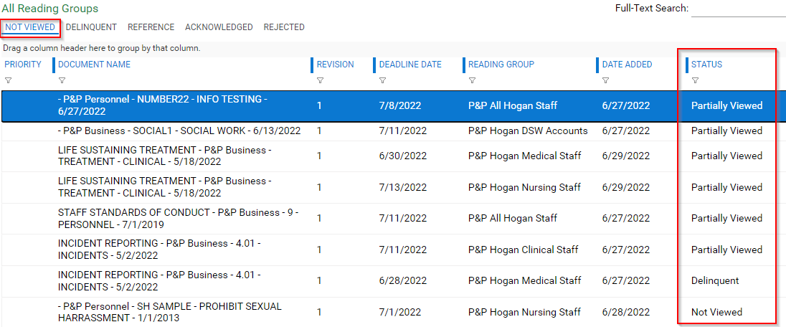
Unread and Unacknowledged documents are in the Not Viewed tab.
Documents that have not be viewed are Not Viewed.
Documents that have been viewed but not Acknowledged are Partially Viewed.
Documents that have not been Acknowledged (whether viewed or not) and are past the Deadline Date are Delinquent.

Delinquent
The Delinquent tab includes only documents that are past their acknowledgement Deadline Date.
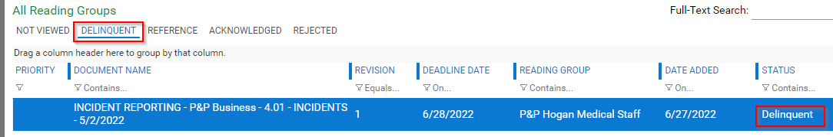

Reference
The Reference tab lists documents you have added as a Reference, for easy access.
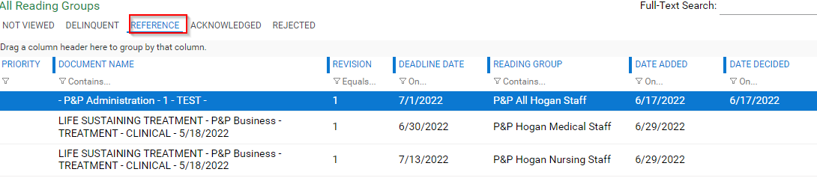

Acknowledged
The Acknowledged tab lists all documents you have Acknowledged.
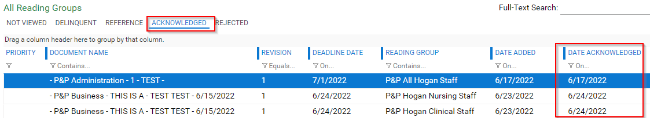

Rejected
The Rejected tab only shows for All Reading Groups. It isn’t currently used in this solution.
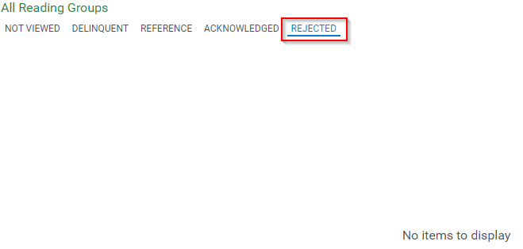

Document List Refinement
The document list can be refined to help you organize or find the documents you want.

Sorting the List
Clicking a heading will sort the list. It will first sort ascending, then descending.
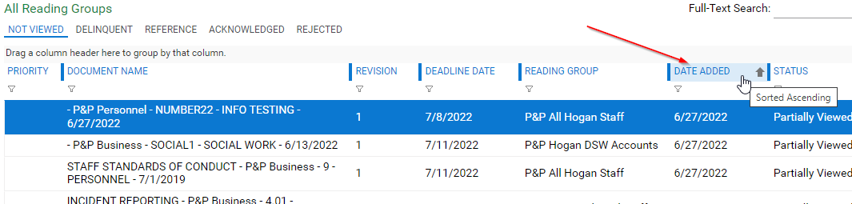

Filtering the List
Underneath each heading is a filter field. By typing in a value, you can narrow the list to items that share that value.
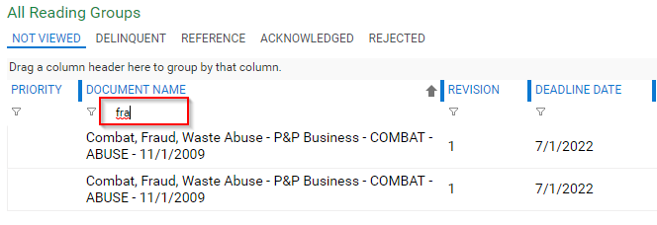

By clicking the funnel icon, you can change the filter type or clear the filter. Contains is the most common filter type for text values.
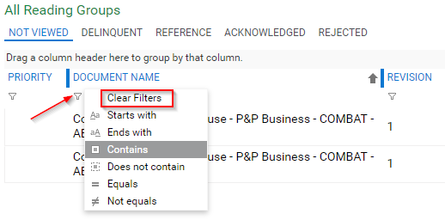

Grouping the List
To group the documents, drag the column heading to the space just above it.
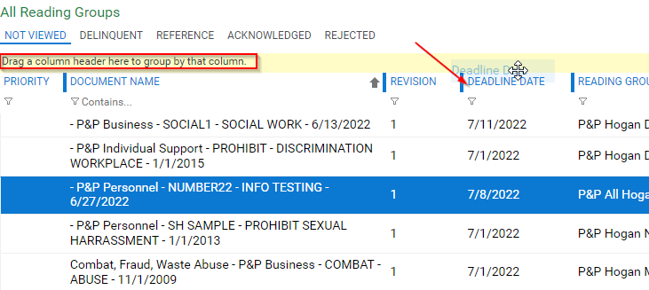

This list is now grouped by Deadline Date.
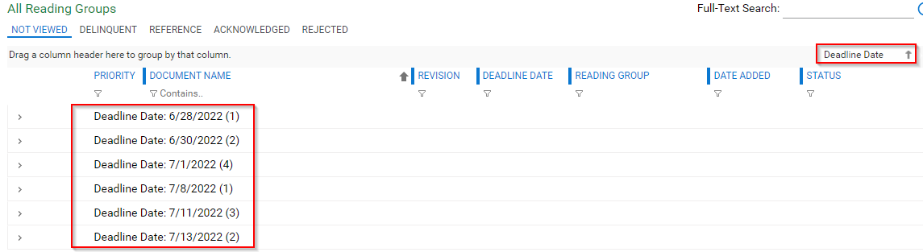
To see the documents in a grouping, click the > in the left column.
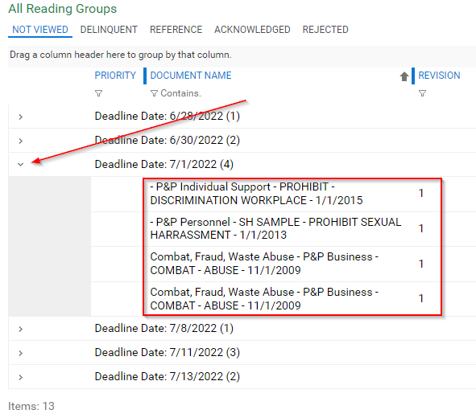

To remove a grouping, find the column name in the grouping row, then click X
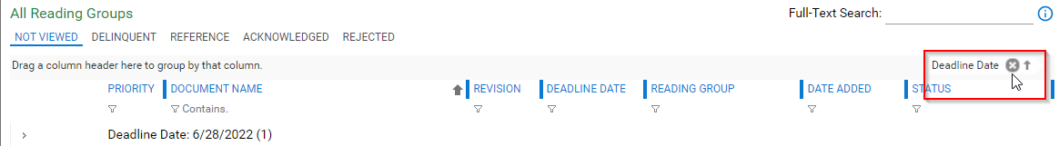

Viewing a Document
To view a document, double-click it in the list.
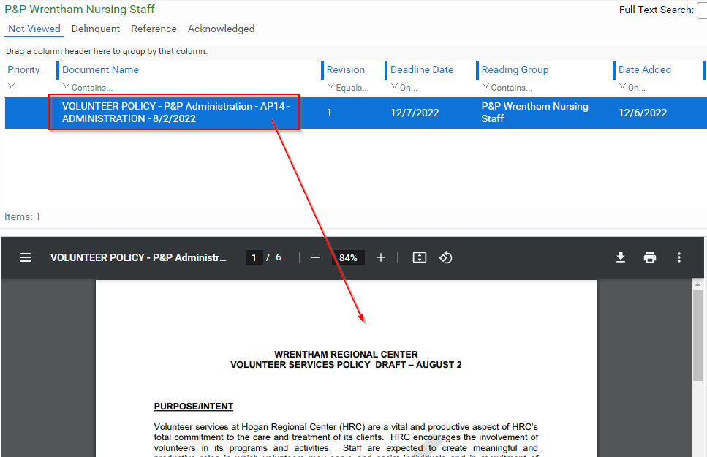

Depending upon your browser and version of Adobe Acrobat, you may have different options. To zoom in or out, use the -, +, or % controls.
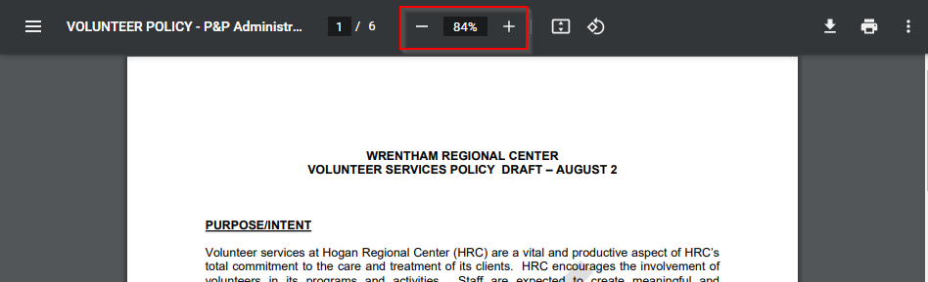

The page control and scroll bar allow you to move through the document.
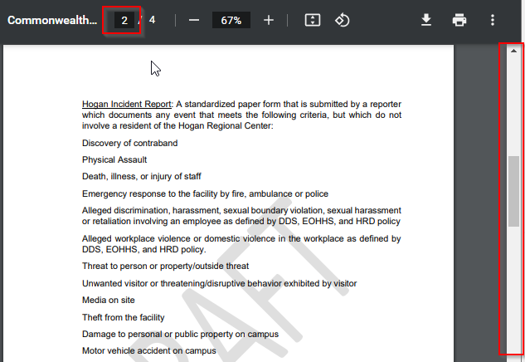

Acknowledging a Document
When viewing a document, you can Acknowledge it if it hasn’t yet been. Click the Acknowledge button.
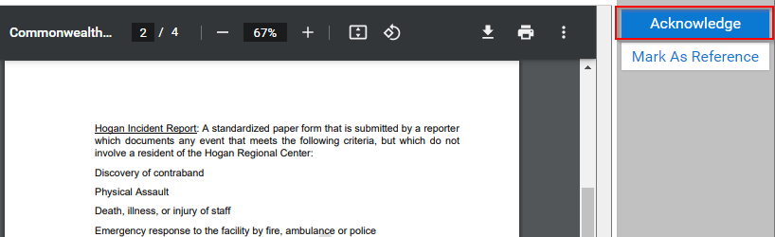

This will present a pop-up message explaining that Acknowledging means you’ve read, understood, and will abide by the policies or procedures described in the document. Click Yes. If you click No, the document will remain in your Not Viewed tab and eventually go Delinquent.
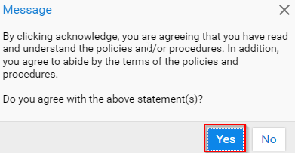

Adding as a Reference
Before or after acknowledging a document, you can mark it as a reference. This allows you to find it faster in the Reference tab.
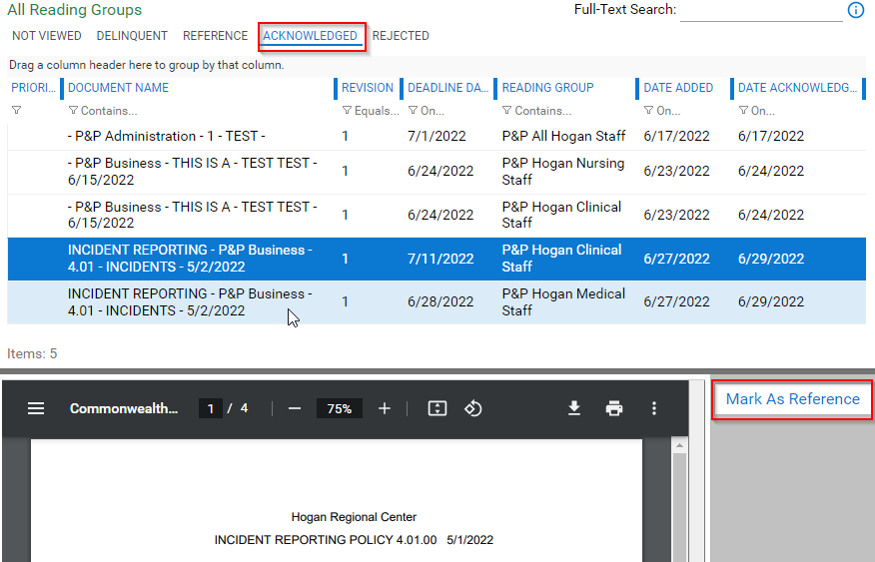

Removing from Reference
When you no longer need the document as a reference, you can remove it from the tab by viewing and clicking Remove from Reference.
