User Guide – Policy Approval Workflow /
Policy & Attestation
CoMA EOHHS - Dept. of Developmental Services
9/6/22

Table of Contents
Document Properties 2
Version History 2
Accessing Policy & Procedures Documents 3
Home Page 3
Document Retrieval 3
Searching for Documents 4
Import New Policy/Procedure Document 5
Begin a New Revision 7
Adding a Revised Policy to the Workflow 9
Policy & Procedures Approval Workflow 10
Open the Policy & Procedure Approval Workflow 10
Workflow Interface 10
Filtering the Inbox 12
Revise 13
Originator Workflow 14
Assign Reviewers 14
Assign Reading Groups 15
Send to Initial Review 16
Edits Complete, Return 17
Remove from Review 17
Initial Review 17
Reviewed with Edits 17
Reviewed No Edits 18
Legal Review 18
Reviewed with Edits 18
Reviewed No Edits 18
Skip Legal Review 19
Final Review 19
Reviewed with Edits 19
Assign Reading Groups 19
Approved 20
Version Prep 21
Ready to Version 21
Reading Group Update 21
Review Reading Groups 22
Add to Group 22
Assignment Complete 23

Document Properties

Version History
Version | Date | Author | Description
1.0 | 2022.09.06 | Tim Richard | Initial version

Accessing Policy & Procedures Documents
To view, import, and begin new revisions you will need access to:

- OnBase Unity Client


Home Page
The Unity Client opens to display the default home page with a ribbon bar across the top.

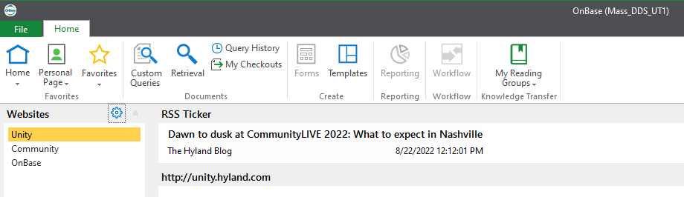

Document Retrieval
From the ribbon bar, you can click the Retrieval icon to open up the Document Retrieval menu
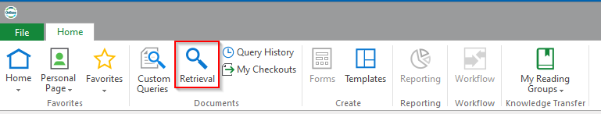

This will open the Document Retrieval menu.
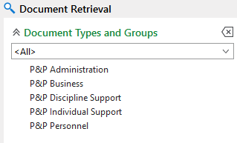

Searching for Documents
From the list of document types, select one or more and then fill out keywords and/or document date to search by and click Find to execute the query. An asterisk (*) can be used as a wildcard in a search term.
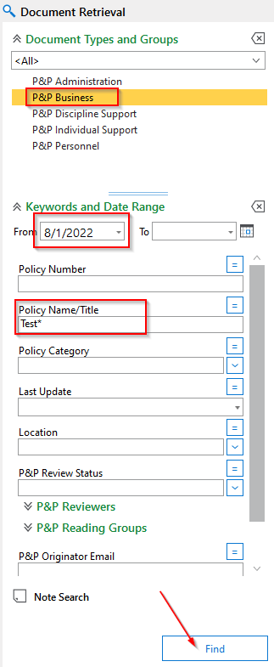

The results are returned in Search Results pane.
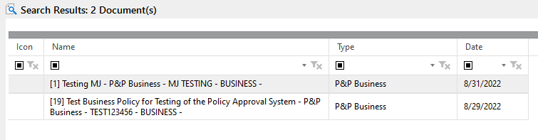

From here, double-clicking on a result will open it up.
PDF documents will be displayed in the OnBase viewer.
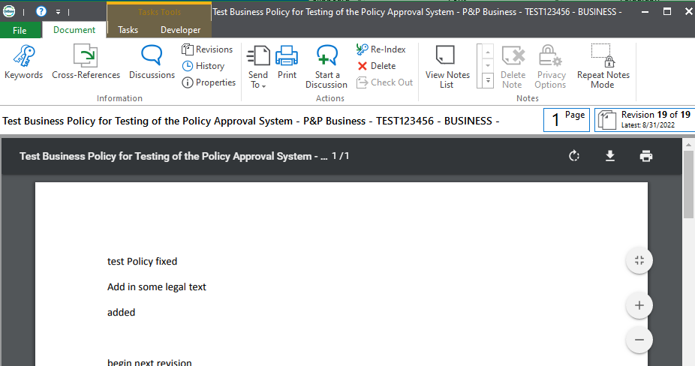

Word documents will display in Microsoft Word.
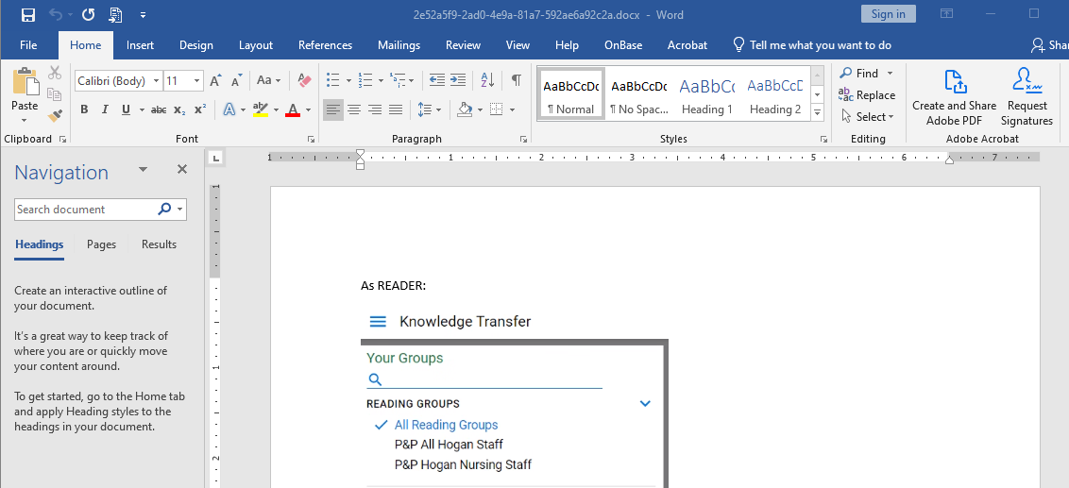

Import New Policy/Procedure Document
To import a new policy or procedure, click Import on the ribbon bar.
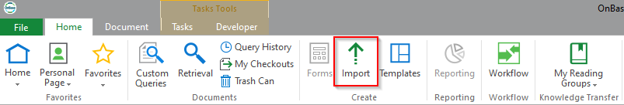

This opens the Import Menu.
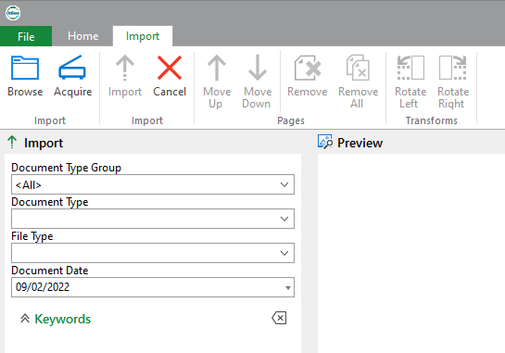

Choose a Document Type, then fill out the keywords Policy Number, Name/Title, Category, and Location.
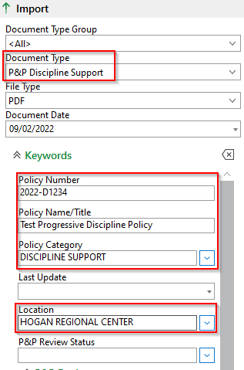

You can then either use the Browse button,
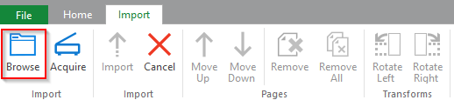

or drag the file into the Preview pane.
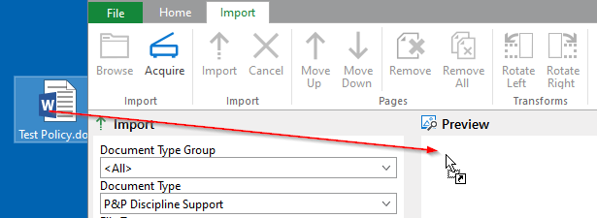

Finally, click the Import button at the bottom of the Import pane to import the file.
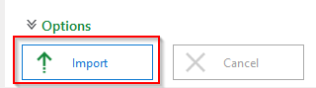

Begin a New Revision
Before starting a review and approval of a revised policy, the document must first be revised from its published PDF version.

Retrieve an existing policy using the Retrieval Menu. From the hitlist, right-click on the document you want to revise and choose Revisions/Renditions.
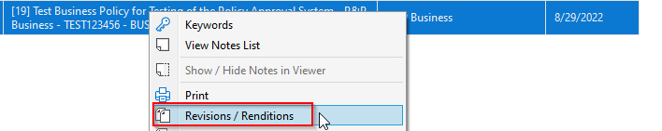

Alternatively, you can choose Revisions from the Document tab in the ribbon bar.
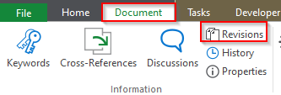

This will open up the Revisions and Renditions menu. In the list diplayed below, the current Revision is 19 and it has both a PDF and Word rendition. The PDF will be the default file type displayed. Double-click the MS Word rendition to display it.
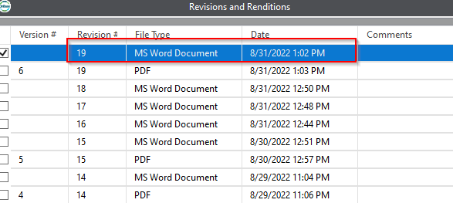

This will open two windows. The Document Viewer window will not display anything.
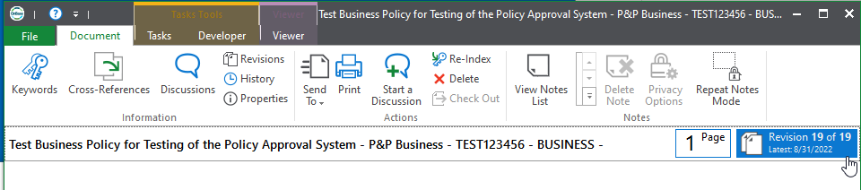

The Word window is used for editing and saving the document.
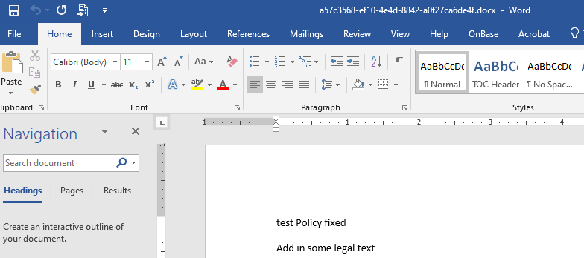

Make some edits to begin the revision and click the Save icon in the top, right.
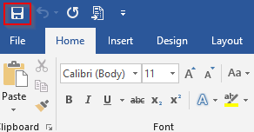

This will invoke a prompt for revising or creating a new document. Choose Save as Revision.
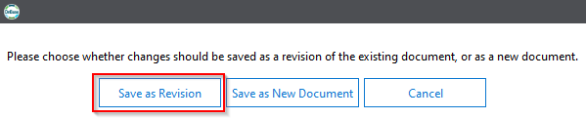
Close the Document Viewer to close the document. This will close both windows.

You can then close the Revisions and Renditions menu.

Adding a Revised Policy to the Workflow
With the revisied policy selected in a hitlist, click the Tasks tab on the ribbon bar. Click the Execute Task drop-down, then choose Revise Policy.
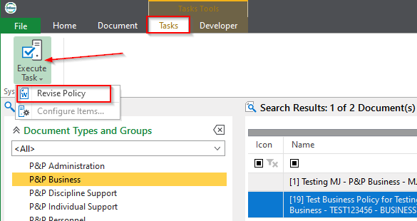

The document will be added to the approval workflow and a message box will pop up when this is complete. Click OK.
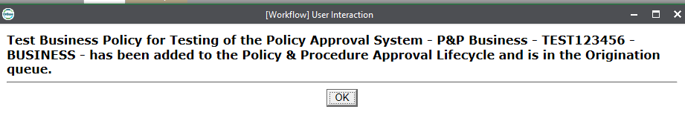

Policy & Procedures Approval Workflow
To review and acknowledge documents you will need access to:

- OnBase Unity Client

Open the Policy & Procedure Approval Workflow
From the ribbon bar, click the Workflow button.
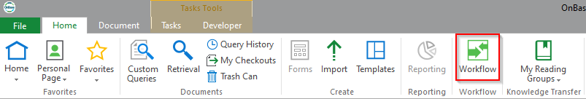

This opens the workflow interface for the Policy & Procedure Approval lifecycle. Depending upon user rights, one or more queues may be displayed.
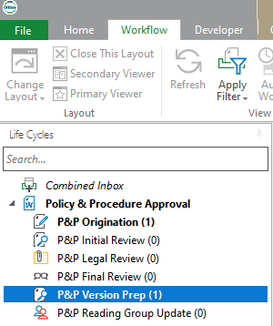

Workflow Interface
The workflow interface is comprised of several areas.

Lifecycles and Queues
The lifecycles & queues pane is typically on the left. It displays lifecycles and queues the user has access to, along with the count of documents in each queue.
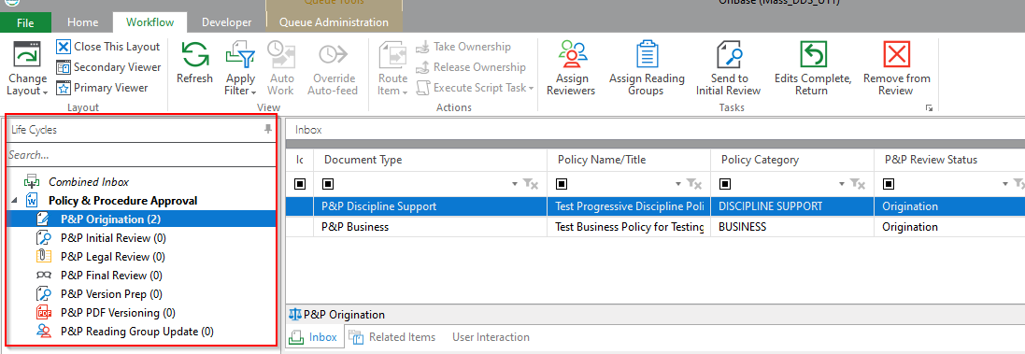

Inbox
The Inbox is where the list of documents in the selected queue are displayed.
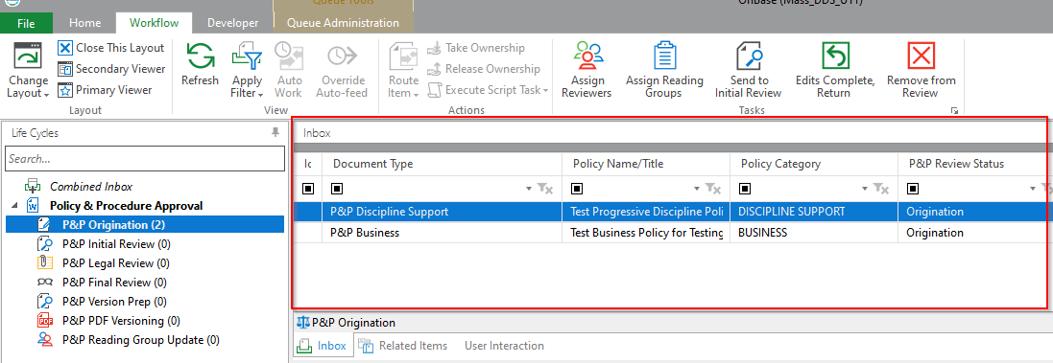

Layout
The layout area of the ribbon bar is where a user can rearrange the layout. Click the Primary Viewer button to display the document that is selected in the Inbox.
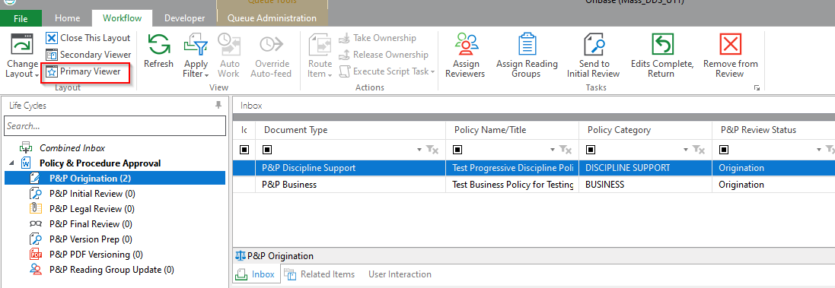

This will open up the Primary Viewer below the Inbox. However, the document will actually display in Word because of its file type.
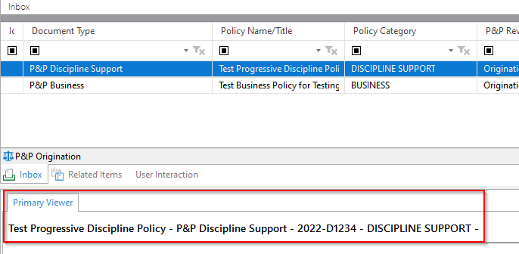

Tasks
Tasks the user can execute on documents are displayed on the right side of the ribbon bar.
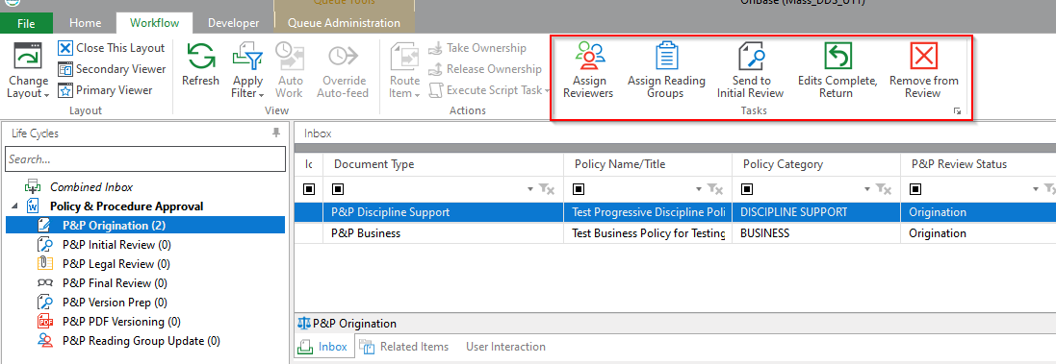

Filtering the Inbox
To filter items in the inbox, type into the field below the column header, or choose from the drop-down.
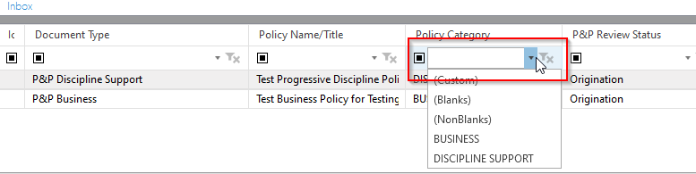

This filters the Inbox.
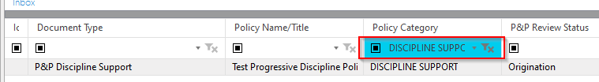

To clear a filter, click the funnel with the X icon.
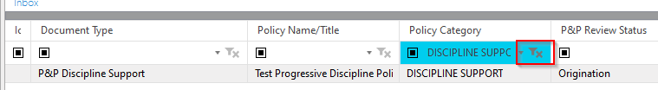

Revise
The users may revise the policy. Once the document is selected in the Inbox it is displayed in Word.
The Word window is used for editing and saving the document.

Make some edits and click the Save icon in the top, right.

This will invoke a prompt for revising or creating a new document. Choose Save as Revision.

Originator Workflow
The Originator is the importer of a new policy or the user that adds the latest revision back to the workflow. The Originator prepares the document for initial review.
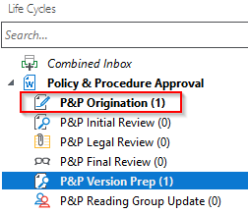

Assign Reviewers
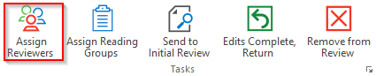
The Originator must Assign Reviewers before sending the policy to the initial reviewers. Upon clicking the button, the Reviewer Assignment form is displayed.
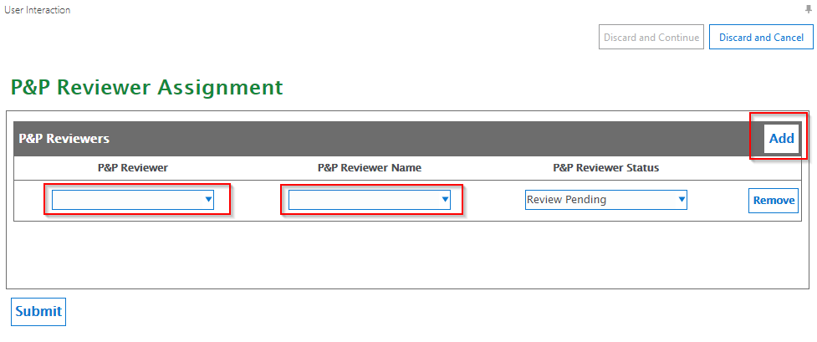
Choose a Reviewer by username or real name. Click the Add button to add more reviewers.
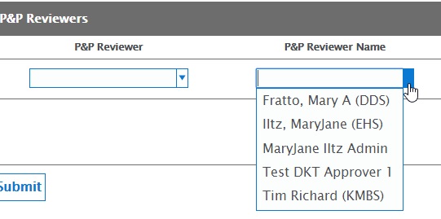

Once the reviewers are added, click Submit to save the changes.
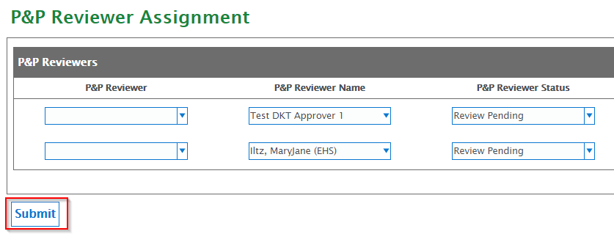

Click Discard and Cancel to cancel the action instead.
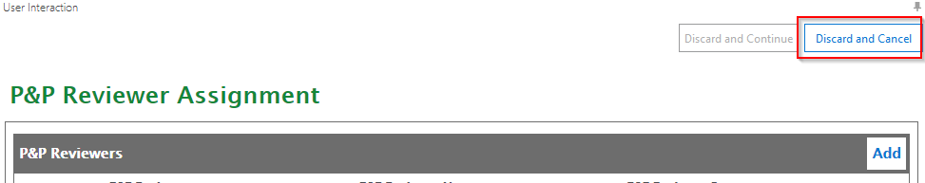

Assign Reading Groups
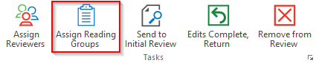
The Originator can suggest reading groups for this policy. Clicking the Assign Reading Groups button displays the Reading Group Assignment Form.
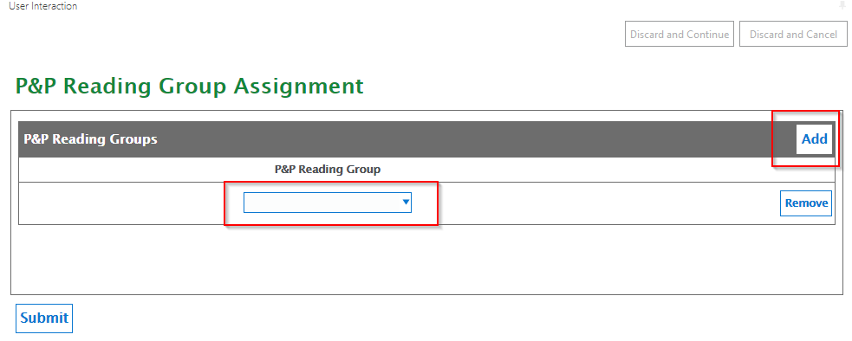

Choose a Reading Group. Click the Add button to add more reading groups.

Once the reviewers are added, click Submit to save the changes.
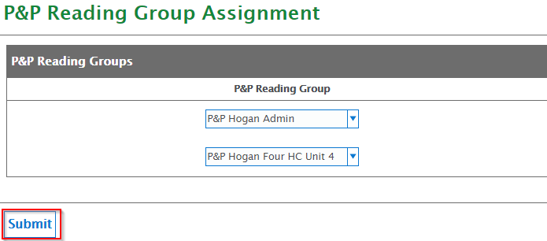

Click Discard and Cancel to cancel the action instead.
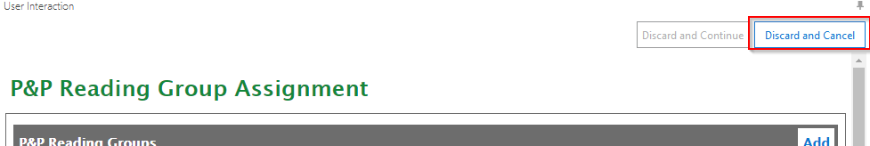

Send to Initial Review
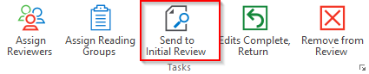
Once the reviewers are assigned, the Originator can send the policy to them for review and comment. Click Send to Initial Review to send the policy on. It will disappear from the Origination queue.

Edits Complete, Return
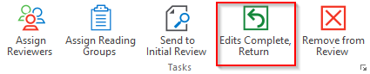
When all the reviewers in a queue are finished, the document is returned to the Originator if any of the reviewers had edits. Once the Originator incorporates the edits and updates the document, click Edits Complete, Return to send it back to the reviewers.

Remove from Review
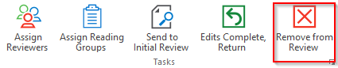
If the policy does not need to be reviewed and revised at this time, click Remove from Review to remove it from the workflow. It can always be added back in with the Revise Policy task.

Initial Review
The reviewers that were assigned to the policy document will be able to access it when the Originator sends it to the Initial Review queue. The Initial Reviewers will receive an email notification when the policy is sent to them. It will remain in this queue until all reviewers have reviewed it.
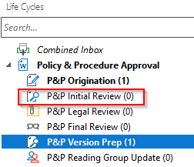

Reviewed with Edits
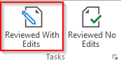
The reviewers edit the policy document directly, with Track Changes activated in Word. When the review is finished, click Reviewed With Edits to return the policy back to the Originator.

Reviewed No Edits
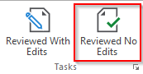
When the review is finished and no edits were made, click Reviewed No Edits to send the policy to Legal Review.

Legal Review
Once the Initial Reviewers have completed their reviews and have no further edits, the policy moves the Legal Review queue. The Legal Reviewers will receive an email notification when the policy is sent to them.
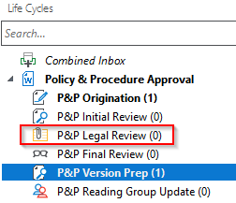

Reviewed with Edits
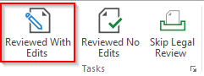
The reviewers edit the policy document directly, with Track Changes activated in Word. When the review is finished, click Reviewed With Edits to return the policy back to the Originator.

Reviewed No Edits
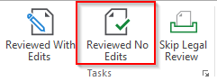
When the review is finished and no edits were made, click Reviewed No Edits to send the policy to Final Review.

Skip Legal Review
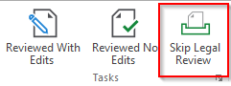
If no legal review is needed, click Skip Legal Review to send the policy to Final Review.

Final Review
Once the Legal Reviewers have completed their reviews and have no further edits or they skip legal review, the policy moves the Final Review queue. The Final Reviewers will receive an email notification when the policy is sent to them.
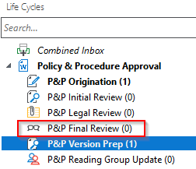

Reviewed with Edits
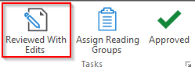
The reviewers edit the policy document directly, with Track Changes activated in Word. When the review is finished, click Reviewed With Edits to return the policy back to the Originator.

Assign Reading Groups
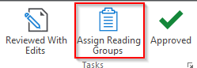
The Final Reviewers decide on reading groups for this policy. Clicking the Assign Reading Groups button displays the Reading Group Assignment Form.

Choose a Reading Group. Click the Add button to add more reading groups.

Once the reviewers are added, click Submit to save the changes.

Click Discard and Cancel to cancel the action instead.

Approved
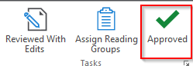
When the all edits have been incorporated and the policy is ready to be published, click Approved to send the policy on for the creation of a new PDF version and assigning it to the reading groups.

Version Prep
Once the Final Reviewers have approved the policy, it moves to the Version Prep queue. Here, the Administrators ensure that Track Changes has been disabled and all comments are deleted. The Administrators will receive an email notification when the policy reaches this state.
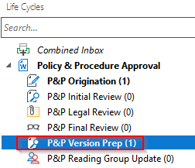

Ready to Version
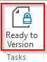
Once the policy is cleared of comments and edit marks, click Ready to Version create the PDF version. The policy is then sent to Reading Group Update

Reading Group Update
Once the Final Reviewers have approved the policy, it moves to the Version Prep queue. Here, the Administrators ensure that Track Changes has been disabled and all comments are deleted. The Administrators will receive an email notification when the policy reaches this state.
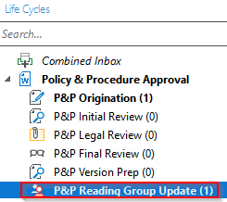

Review Reading Groups
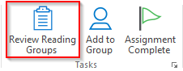
To review the reading groups assigned to which the policy should be assigned, Click the Review Reading Groups button, this displays the Reading Group Assignment Form.

Click Discard and Cancel to cancel the action instead.

Add to Group
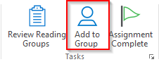
Click Add to Group to add the policy to a reading group.

This will open a prompt to choose a reading group. Choose a group from the drop-down and click Add to add the policy to a group. Repeat for every group to which this needs to be added.
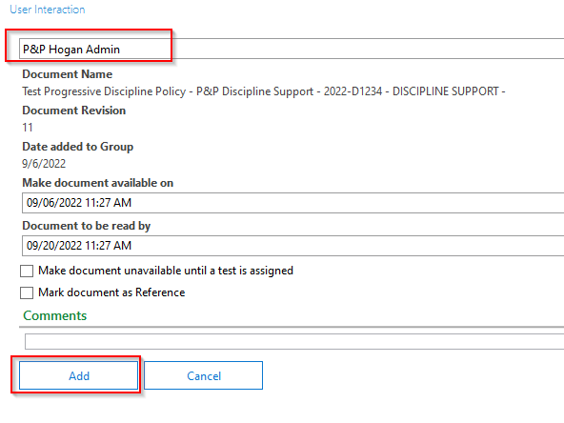

Assignment Complete
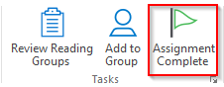
Once the policy has been added to all of the reading groups, click Assignment Complete to remove the policy from workflow.

